GET Request:

1. <http://dummy.restapiexample.com/api/v1/employees>

Type: JSON

Description : Get all employee data

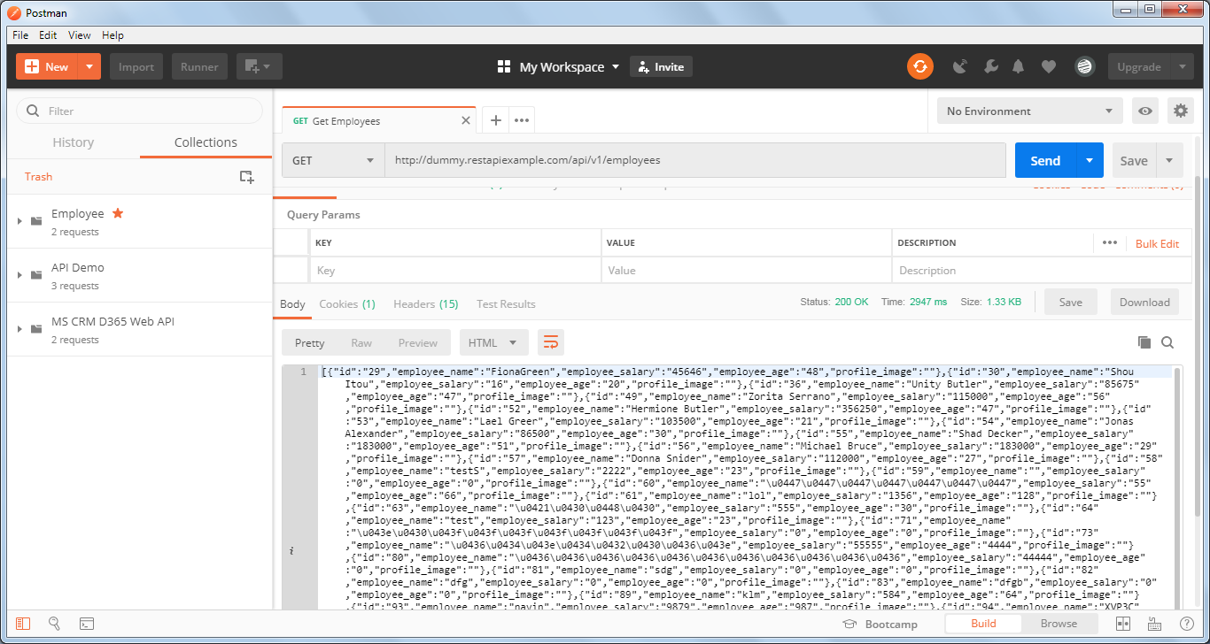

Request Headers

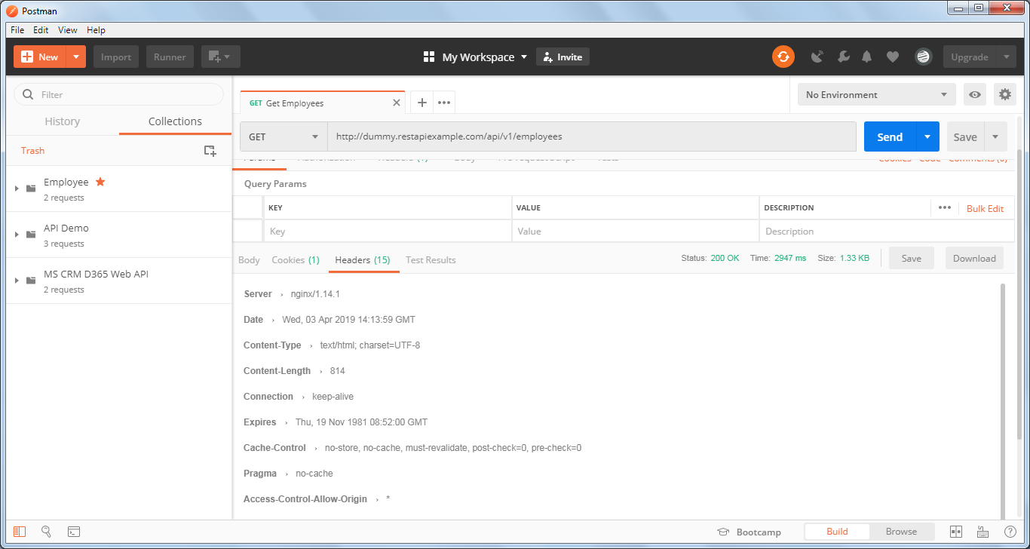

Raw Response:

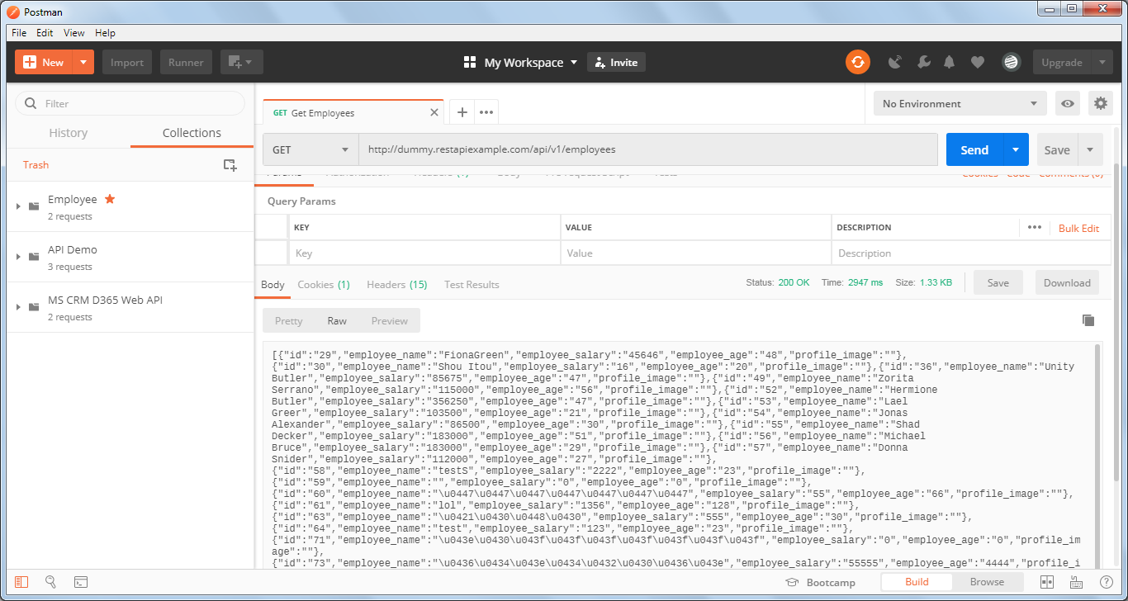

POST Request:

<http://dummy.restapiexample.com/api/v1/create>

Type : JSON

Description: Create new record in database

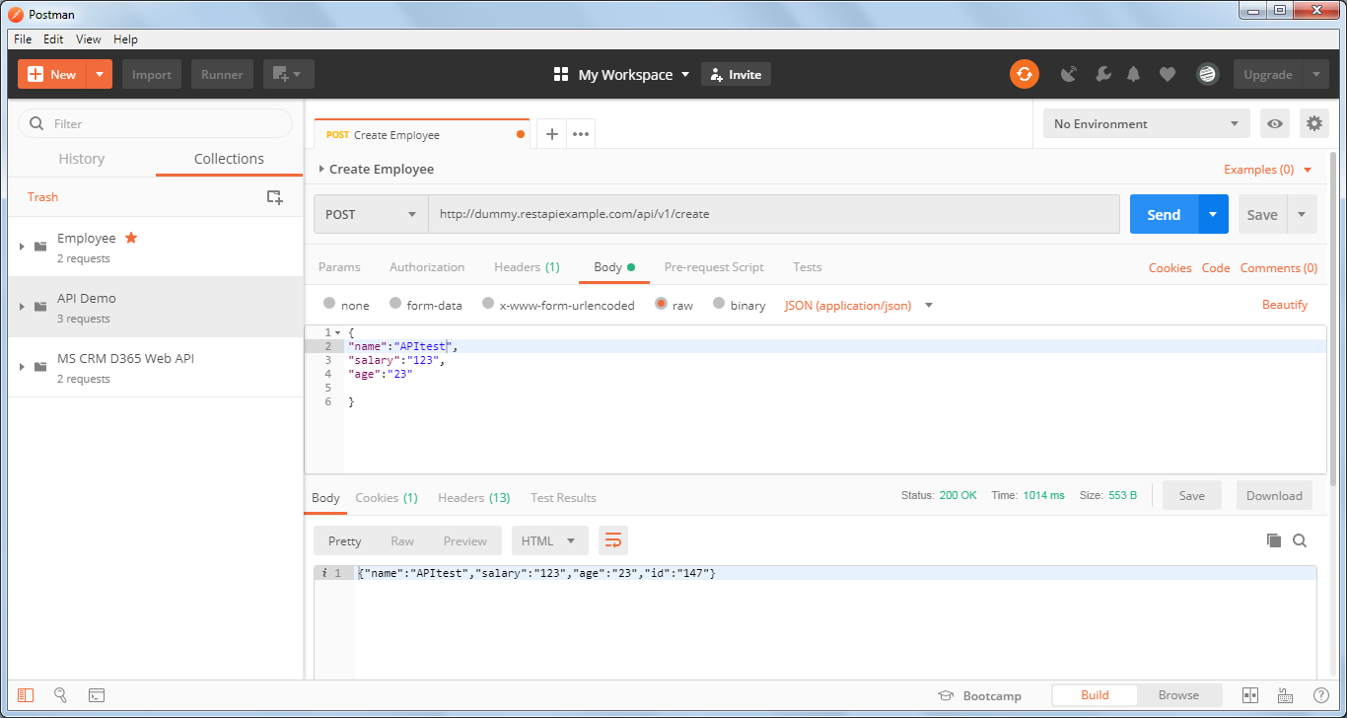

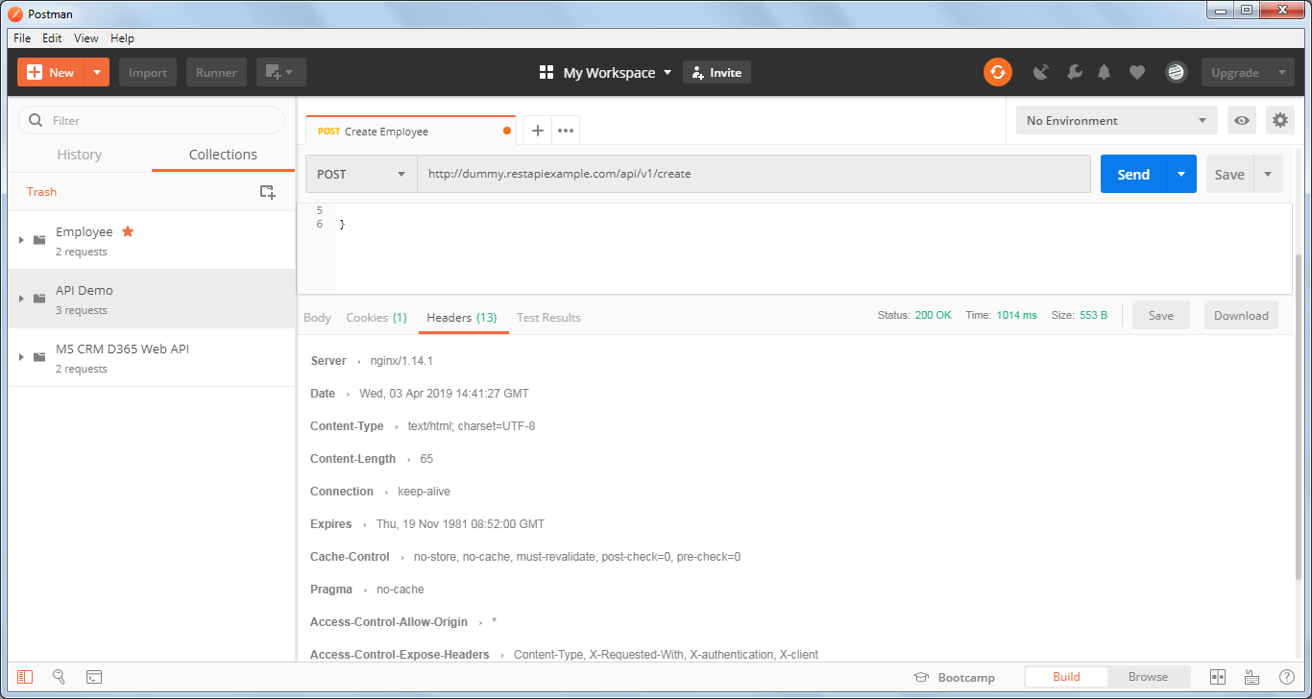

GET Request by ID

<http://dummy.restapiexample.com/api/v1/employee/1>

Type: JSON

Description: Get a single employee data

